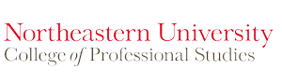
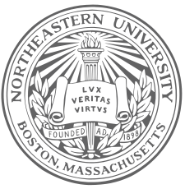
Northeastern University Peru Dialogue of Civilization 2014
Certificate of Participation

In Recognition of Professional Achievement for Successfully Participating in the Cultural Exchange Program Between Northeastern University

(Boston, Massachusetts) and the Air Force School, “Jose Quinones” (Lima, Peru). Your Hard Work and Enthusiasm Are Characteristics That Made Possible the Successful Completion of This Program, Held May 26 – 30, 2014

at IE Jose Abelardo Quinones School.

Is Awarded To
[Recipient Name]

As Presented By Northeastern University On This 30th Day of May Two Thousand and Fourteen
Yanet Canavan
Director of Cultural Activities

